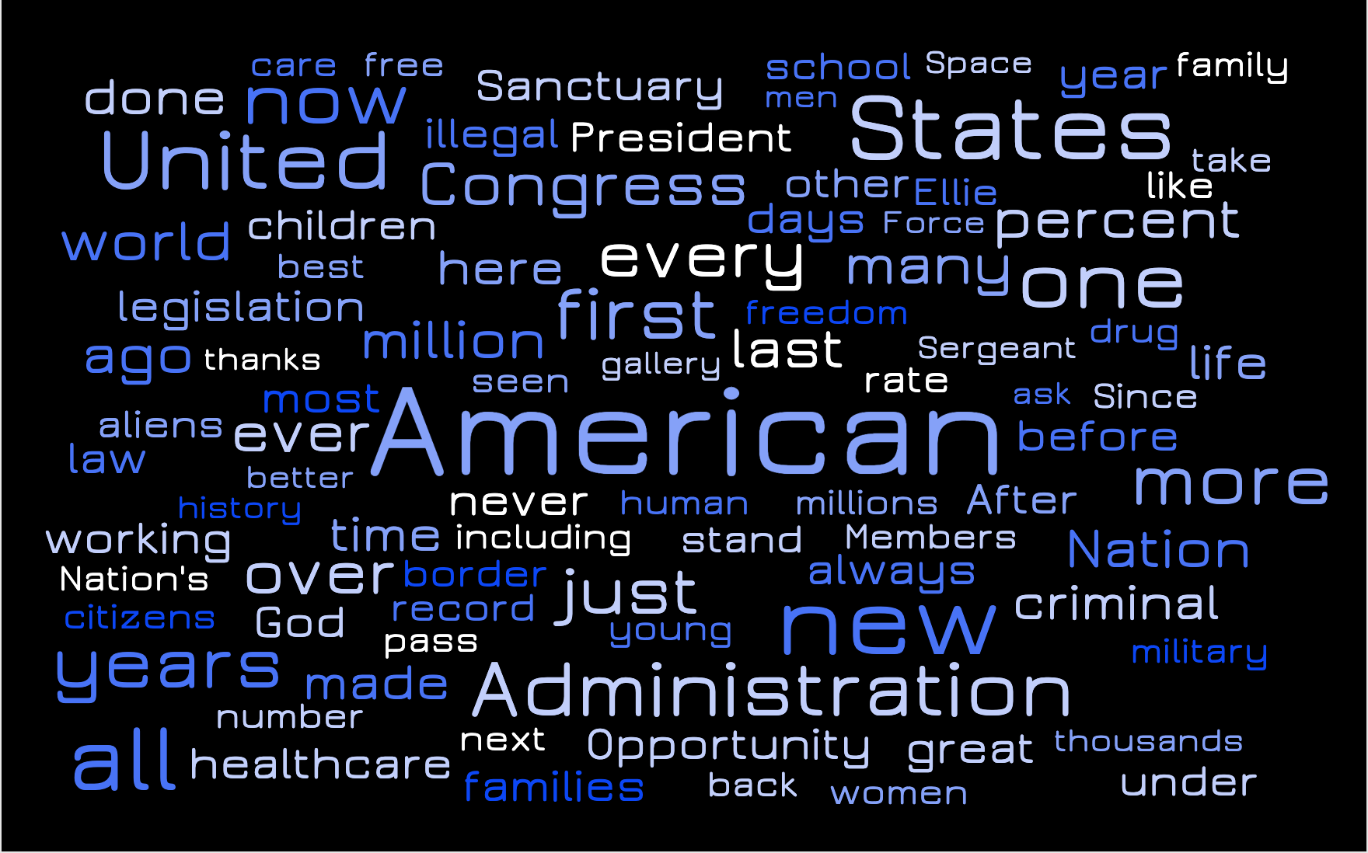

President Donald Trump’s third and final State of the Union address on February 4th, 2020, largely focused on many of his administration’s “America first” priorities. In one of the longest addresses to the nation, President Trump referred to America directly at least 91 separate times and highlighted his recurring domestic concerns. On the heels of heightened controversies surrounding the wall at the southern border, President Trump doubled down on his security policies and criticized legislators in the audience for endorsing bills that would provide healthcare to undocumented immigrants. He also directly named cities and states that have embraced sanctuary laws and cited these local policies as cause for criminal behavior.